Completed Project Final Copy
Alvin Lugo
CMGT/554
University of Phoenix
Matthew Mancani
Date

Executive Summary of Business Requirements of International Plastics Inc
The following summary describes the business and operational environment of International Plastics Inc, a manufacturing company that specializes in the creation of custom plastic products. International Plastics Inc., operates in four main locations which include the United States and China, with three locations located within the United States, while the fourth is in China. All four locations of the company are connected through a Wide Area Network (WAN), with firm headquarters located in San Jose, California where all the operations are centralized. If it wishes to remain a world leader in the manufacturing industry, International Plastics Inc., must ensure appropriate investment in infrastructure to remain productive and efficient in internal processes to ensure future stability. In the CEO’s directive, he highlighted this need and prioritized a modernization of the existing structure in which the main aim was not only to improve production and efficiency but to also reduce costs.
Based on the diagrams provided to our team of analysts we can see the infrastructure and the current operational environment in the International Plastics Inc and from these diagrams we have identified the key features of the hardware infrastructure. All four locations are equipped with advanced IT infrastructure but that with current design not all goals are being met. After consulting with the management, it was understood that there would need to be an intensive analysis further needed to gather requirements.
There were a few key goals that were discussed that we will look to accomplish upon completion of gathering requirements. We will explore ideas to improve the existing enterprise network through the improvement of hardware and software. We will modernize the current capabilities of the organization by including the ability to work while mobile and certain employees will be issued tablets and smartphones to ensure they are connected to our network while out and about. This will include having our own proprietary software with all business functionality contained within these devices with security being prioritized and monitored by administrators. We will additionally look to incorporate helpful applications that would provide real-time market and office data to assist with critical decisions for management and all employees throughout the day.
If International Plastics Inc. wishes to remain a world leader in the manufacturing of plastics, then it must evolve with the times. It must explore and embrace the cutting edge as so many other successful organizations have because failure to evolve could lead to falling behind competitors in efficiency which can hamper productivity. It is highly recommended that you employ our recommendations so that we can continue profitability and remain a world leader for many years to come.
Proposal
E-commerce has become the modern way of doing business across the globe with the aim to outperform competitors through more efficient operations and superior marketing. The goal is to develop an effective strategy, different from others, to acquire adequate market share for increased revenue. To deliver our products to the eventual end-user we need to utilize every available method and with current market trends, an e-commerce platform through which the products can be advertised and sold online would be most beneficial. Majority of the businesses view an e-commerce as a tool for the growth of the business (Chaffey, 2007). Customers can view products online, place an order to buy the product and handle miscellaneous business functions off a quality company marketspace.
The main advantage in e-commerce is its efficiency, which enables businesses and individuals to perform business functions more smoothly. We have identified the need for International Plastic Inc., a robust platform that would be utilized by staff, suppliers, and customers. Through this platform, staff, suppliers and customers can shop, check on orders, and communicate with staff about any issues. It is of the utmost importance that this platform is mobile friendly since this method of business has been gaining in popularity and will only increase in the future.
Electronic Retailing
Electronic retailing is the method of selling goods and services to customers and other businesses through an online marketplace. This approach enables consumers to find goods and services from the internet, pay online and to coordinate product delivery to the designated location. The advantage of this service is that there is no longer a need to go to a physical store for goods, or services. For International Plastic Inc. to benefit from eCommerce, some things should be in place (Shim et al. 2013). They must make sure they build a superior brand for their products, a well marketable website and ensure an efficient product distribution process. A quality website will enable them to locate product quicker and easier because it is essential that the customer receives product in the shortest time possible upon the order. Any delays in the delivery process could negatively affect the customer experience which could potentially hurt business.
International Plastic will be better situated to succeed if the above suggestions are taken into consideration because projected sales would increase and our customer base’s needs would be better satisfied. With this, customer loyalty is thus improved and can realize the economies of scale (Fullan, 2011). There is a potential issue that must be accounted for while pursuing improvements to our existing eCommerce infrastructure. Initially, there will be increased costs associated with improving the infrastructure while moving goods to and from the customers.
Market creator
The market creator is the digital provider of the business environment, which is the meeting point between buyers and sellers. Buyers create product displays, and determine the pricing of products. Customers search for products, compare pricing from different sellers and eventually decide to place an order to buy or not, based on existing options.
To preserve a competitive advantage, International Plastic must strive to build a good relationship with all players in the market. A good working relationship based on trust must be established and maintained with suppliers and middlemen. Customers must be informed through all phases on an order so that they know where their product is at, along with an approximate schedule for delivery. We must welcome criticism from customers through surveys and a helpline so that we constantly improve our service and overall company image. Failure to remain competitive, would jeopardize market share and long-term growth.
Functional Requirements
For any business to thrive, the excellent working environment must be provided as one of the primary requirements (Fullan, 2011). Qualified workers, loyal customers, and a robust marketing strategy are the ingredients of a successful business. International Plastic must utilize our robust approach elevate to a new level to remain a market leader.

Conclusion
International Plastics needs to upgrade its infrastructure to improve business through eCommerce, which will better position itself in the market for the foreseeable future. To make this happen, a comprehensive analysis will be done to ensure the appropriate allocation of resources to ensure the employment of our plan. Profit growth and market expansion will be the fundamental goal of this plan and it will be done through our recommended strategy implementations which will ensure success.
Incorporating IT Infrastructure in Soft Ware Applications
Infrastructure refers to the foundation or the overall framework that provides support to the system or organization. Information technology infrastructure comprises of virtual and physical resources that support processing, storage, flow, and analysis of data within a given data center (Shinder, 2005). Moreover, these resources may be decentralized and distributed across various data centers that are either managed by the organization or by third party like collocation facility or cloud provider.
On the other hand, the software application refers to a program specifically designed for the end user. They are also called the end user programs. These programs rely significantly on the IT Infrastructure in the execution of their operations. Software applications include word processors, web browsers, spreadsheets, and database programs. For instance, the built-in data center for the database program utilizes the IT Infrastructure in storage sub-systems, servers, networking devices like routers and physical cabling. The web browser (Chrome, Edge, and Mozilla) utilizes the IT Infrastructure through provision of simplified view of what happens in the webpage. Precisely, the infrastructure is essential for writing web code in the short term. Furthermore, web browsers play a major role in the retrieval, presenting, and traversing data on the World Wide Web (Payne, 2004). Thus, web browser must have access to IT infrastructure before executing such function. On the other hand, word processing requires IT infrastructure to enable effective operation. For example, when typing, the information has to be stored and perhaps be printed through various IT infrastructure devices that will transmit the data to the printers. Furthermore, the system enables proper preservation of the information because some of the data may be saved in the Google cloud.
In the management system plan development, ethics should take major part. For instance, the IT security personnel should take full charge to protect and restrict access to confidential data concerning individuals’ and companies’ networks and systems providing them with vital power. This power can be subjected to deliberate abuse if left unprotected. More so, individual data can be used in tainting or destroying his reputation
The plan can only be justified as being effective if it provides the required results and improve the performance of a given organization. For example, it should ensure safety of the information, enhance communication procedures, and incorporate every stakeholder in the organization. The system should highly integrate vital information concerning the organization such as inventory management and up-to-date individual records. More so, it should provide linkage to other organization to enhance or widen the operating network. The idea will boost the interaction within the organization and other firms. Furthermore, the system should be flexible and should highly fit in the dynamic environmental conditions of the respective industry. Additional, it should harmonize all the production channels within the organization. For example, the management should be able to use it in monitoring the performance of the workers and rate the payment levels to avoid wasting resources and time.
On the matter of current trends and security concerns, the system should ensure protection of data and information from being attacked through cybercrimes. The idea may highly save the organization from financial losses. Likewise, competitors are able to access data from perforated system and use it to their benefit.
Network Diagram Design and Analysis
The current network setup for the company involves the use of a T2 internet link from its MI, Pontiac and Albany, NY branches to its Headquarters. The Chinese branch is also linked to the corporate headquarters via a T3 link as shown in figure 1, 2 and 3 below. These links are very basic, slow and unsecured and should be upgraded to more secure technologies. The Chinese link also has a satellite link to enable a redundant connection to other branches.
Risks
The network in its current configuration is risky and is exposed to availability risks due to the unreliable T1 and T2 links (Canavan, 2001). T1 and T2 leased lined are also expensive to maintain and are subjected to frequent downtimes. T1 and T2 technologies are also easy to intercept and manipulate unlike Fiber and VPN links. What the company needs is a dedicated Fiber Link between the branches. The infrastructure currently relies on old equipment and this makes the ease of catastrophic failure, lack of support and hacker attacks to increase. Diagram 4, 5, 6 and 7 presents what should be done to secure the connections and improve their operations and risk profile. The firewalls must also be appropriately configured.
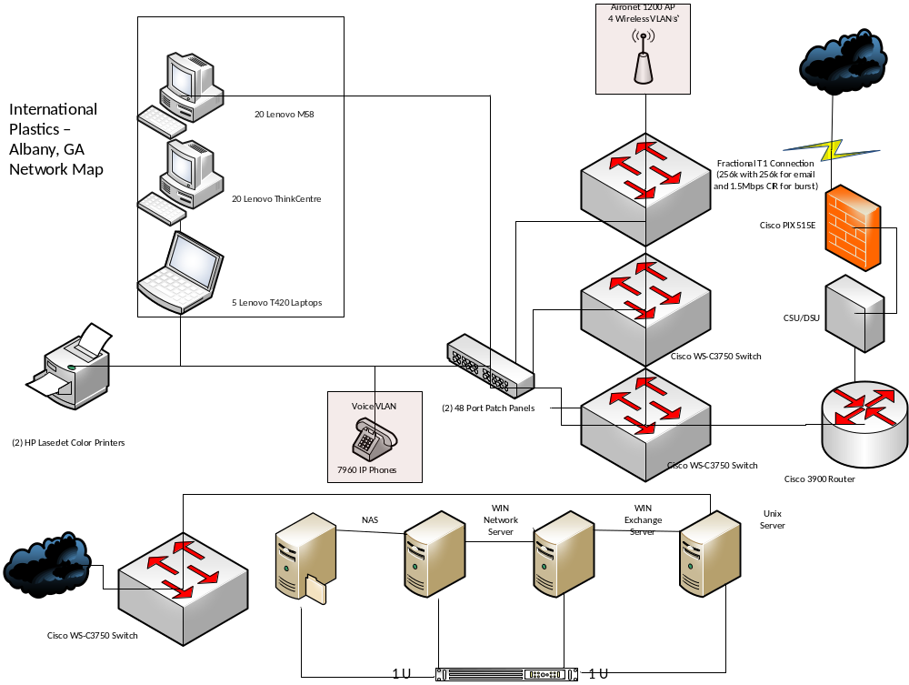
Figure 1.

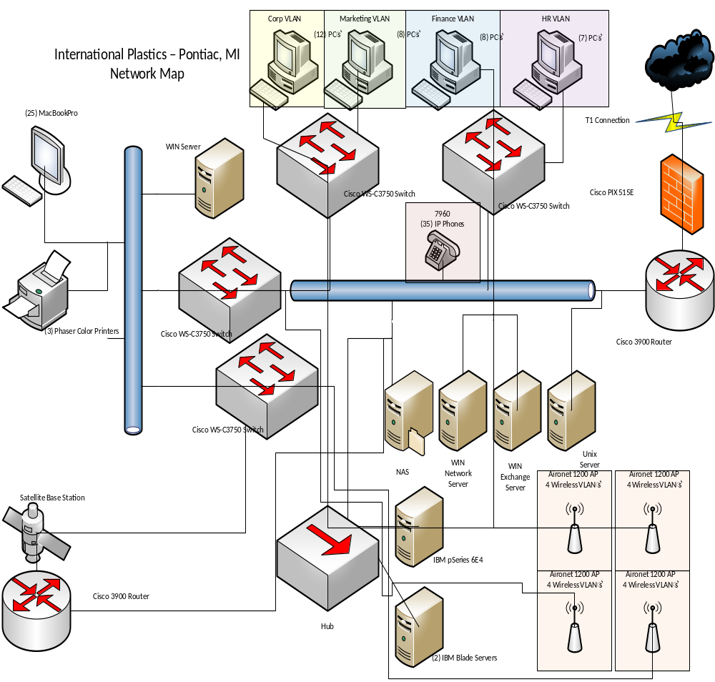
Figure 2

Figure 3

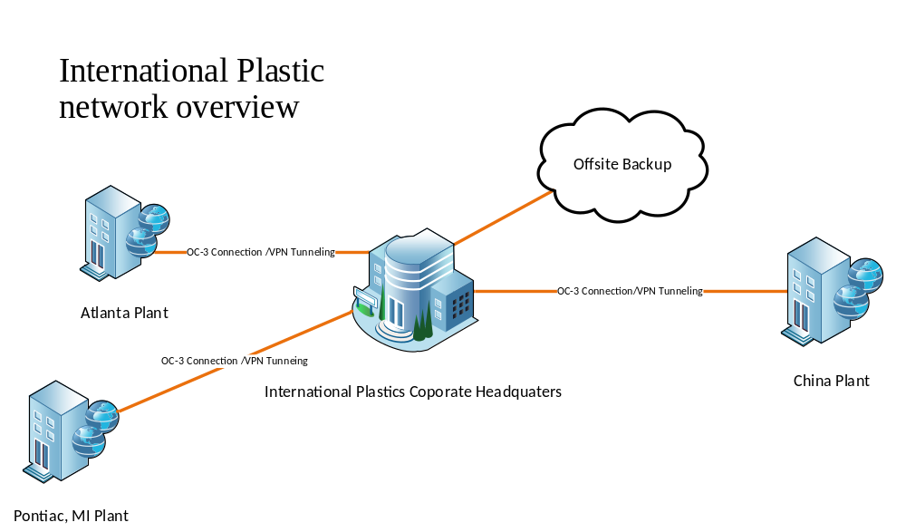
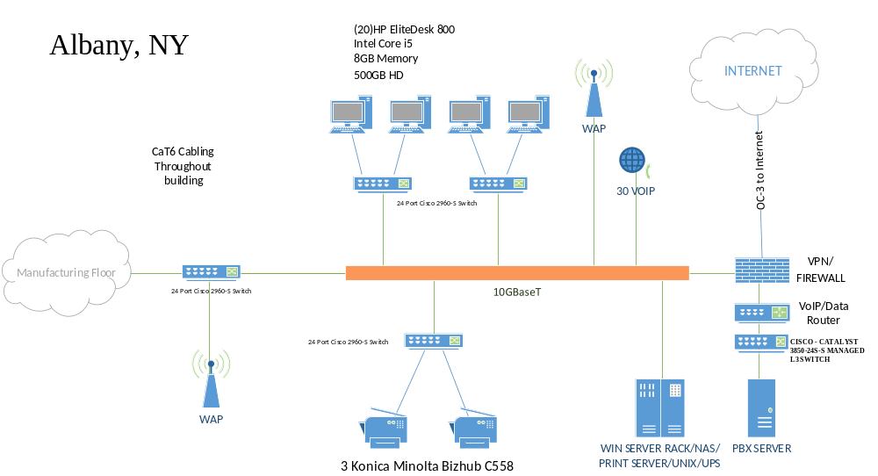

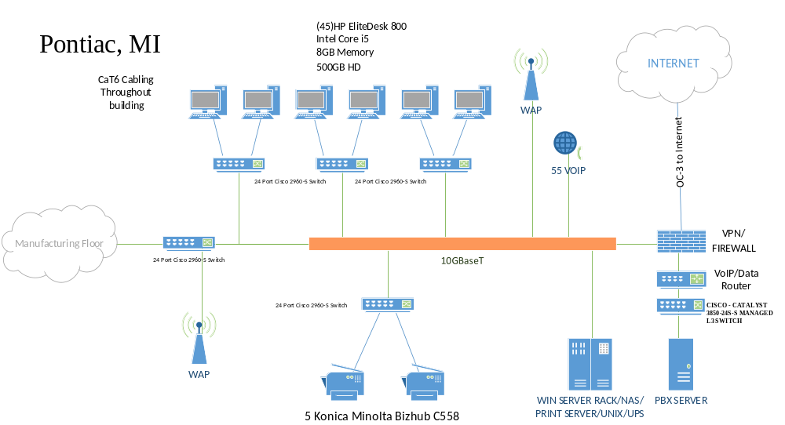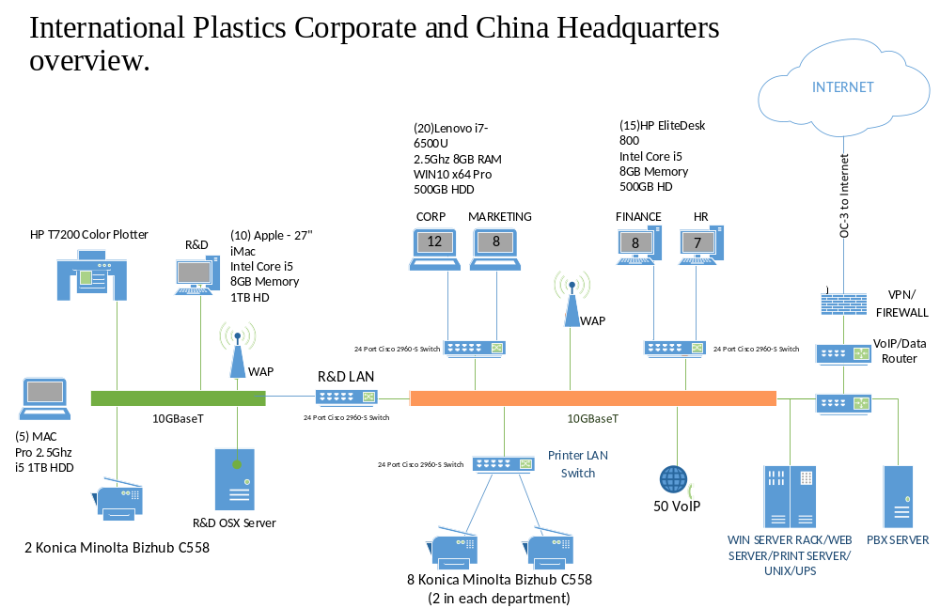
Improvements
The improvements that should be made to improve the risk profile of International Plastics WAN infrastructure includes the conversion of the T1 and T2 links into dedicated OC-3 links with dedicated VPM tunneling. All the connections should be standardized to OC3 links with VPN capability. In order to increase bandwidth, the backbone will be upgraded to 10GBaseT with robust Cat6 cabling to all desktops (Dadarlat, 2008; Stallings, 2001). New computers should also be included in the new infrastructure as shown n figure 5,6 and 7. Secured wireless points should also be added to the infrastructure to enable mobility within the organization.

References
Canavan, JE (2001). Fundamentals of Network Security, Artech House, Boston, London
Chaffey, D. (2007). E-business and E-commerce Management: Strategy, Implementation and Practice. Pearson Education.
Dadarlat, V (2008). Types of Computer Networks and their Topologies, Cisco based computer
Networks
Deb Shinder. (2005, August 2). Ethical issues for IT security professionals. Retrieved from https://www.computerworld.com/article/2557944/security0/ethical-issues-for-it-security-professionals.html
Fullan, M. (2011). The six secrets of change: What the best leaders do to help their organizations survive and thrive. John Wiley & Sons.
Laudon, K. C., & Laudon, J. P. (2018). Management information systems: Managing the digital firm.
Payne, L. S. (1994, March 1). Managing for Organizational Integrity. Retrieved from https://hbr.org/1994/03/managing-for-organizational-integrity
Stallings, W (2001). Cryptography And Network Security Principles And Practice Fifth Edition,
Prentice Hall
Shim, J. K., Qureshi, A. A., Siegel, J. G., & Siegel, R. M. (2013). The international handbook of electronic commerce. Routledge.

